Predicting Customer Churn Using Classification Trees
BY: Colin Wilson & Sasha Biesecker

Introduction
In today’s highly competitive telecom market, customer retention is more crucial than ever. Our team set out to address a pressing issue facing telecom companies: customer churn, or the rate at which customers leave the company. High churn rates not only reduce revenue directly but also inflate marketing and onboarding costs associated with acquiring new customers. Therefore, predicting which customers are likely to leave is vital for maintaining profitability and ensuring long-term success.
Using a dataset of telecom customers, we found that approximately 26.4% of customers had churned. This level of churn presents a significant risk to the company, especially given the fierce competition in the telecom industry.
To understand what factors contribute to customer churn, we conducted a preliminary analysis using cross-tabulations. Our goal was to identify which characteristics are most strongly associated with a customer's likelihood to leave.
Preliminary Analysis
We examined how various customer characteristics correlated with churn, including contract type, internet service, phone service, security service, tenure, and monthly charges. Here are our key findings:
- Contract Type had one of the strongest effects. Among customers with month-to-month contracts, 43.1% churned. In contrast, only 11.2% with one-year contracts and 2.8% with two-year contracts churned. This suggests that long-term contracts greatly reduce the likelihood of churn.
- Internet Service users were more likely to churn. 31.4% of customers with internet service churned, compared to just 7.4% of those without it.
- Phone Service users showed a smaller difference, but still meaningful. 28.1% without phone service churned, compared to 25.6% of those with it.
- Security Service appeared to correlate as well. 30.3% of customers without security churned, while 21.8% of those with it churned.
- Tenure (time with the company) also mattered. In the lowest tenure bin (0–12 months), 49.5% churned. In the highest tenure bin (60–72 months), only 4.5% churned. Clearly, longer relationships reduce churn risk.
- Monthly Charges showed an interesting trend. Customers in the highest price bracket ($175–$200) had a 54.3% churn rate, compared to only 11.4% for those paying less than $25/month.

The data strongly suggests that customers with short contracts, low tenure, high monthly bills, and minimal service add-ons are at higher risk of leaving.
Supporting Tables
Here are two summarized tables that highlight critical trends:
Table 1: Churn Rate by Contract Type
Contract Type | Churn Rate
Month-to-Month | 43.1%
One Year | 11.2%
Two Year | 2.8%
Table 2: Churn Rate by Binned Monthly Charges
Monthly Charges | Churn Rate
$0–$25 | 11.4%
$175–$200 | 54.3%
These findings informed our model development in the next phase.
Model Building and Evaluation
To predict churn more accurately, we built a classification tree model using a decision tree algorithm. We excluded raw tenure and monthly charges in favor of the binned versions to simplify model interpretation.
Using an 80/20 data split, we trained the model on 4,000 customers and validated it on the remaining 1,000. The model was trained using the rpart library and visualized using rpart.plot. It considered multiple predictors, including contract type, services used, and customer demographics.
On the training set, the model achieved the following:
- Accuracy: 85.6%
- Misclassification Rate: 14.4%
- Sensitivity (Churn 'Yes'): 66.8%
- Specificity (Churn 'No'): 95.5%
On the validation set, the model performed similarly:
- Accuracy: 85.0%
- Misclassification Rate: 15.0%
- Sensitivity (Churn 'Yes'): 63.9%
- Specificity (Churn 'No'): 95.8%
These results indicate a strong model with high predictive power, especially in correctly identifying customers who are likely to stay. While sensitivity could be improved to better catch churners, overall accuracy and specificity are quite strong for a first model.
Customer Risk Profiles
By interpreting the decision tree, we identified key customer profiles that indicate a high risk of churn:
- Short-Term, High-Cost Users: Customers who have been with the company for less than a year and are paying more than $100/month are among the most likely to churn.
- Month-to-Month Contract Holders: These customers lack a long-term commitment and showed a churn rate of over 40%, making them prime targets for intervention.
- Minimal Services Customers: Customers who do not use security or phone services also tend to churn at higher rates.
Understanding these at-risk groups allows the telecom company to proactively intervene with loyalty offers, service bundling, or tailored promotions to improve retention.

Model Development

We constructed our classification tree model with the goal of predicting customer churn. The target variable was set to Churn, which is a binary variable indicating whether a customer has left the service (Yes) or stayed (No).

Decision Tree
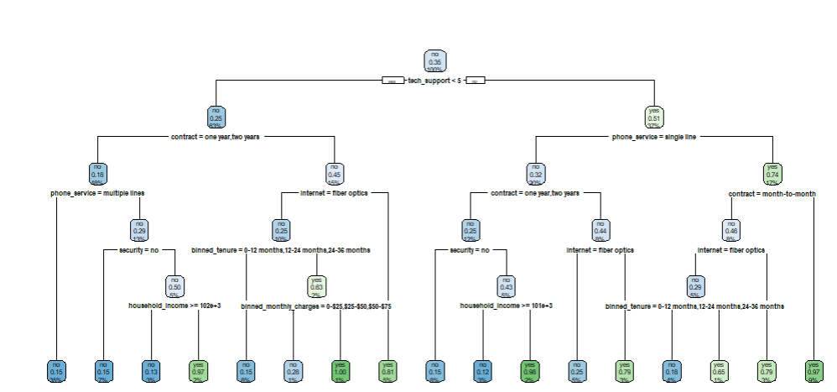

Model Accuracy for Training Data

- Accuracy: 85.6%
- Misclassification Rate: 14.4%
- Sensitivity (Churn 'Yes'): 66.8%
- Specificity (Churn 'No'): 95.5%

These results show that the model maintains a strong performance on unseen data. The overall accuracy of 85.6% indicates that the model correctly predicts whether a customer will churn or not in the majority of cases.
The sensitivity of 66.8% means that the model correctly identifies about two-thirds of the customers who are likely to churn. While this is lower than the model’s specificity, it is still a reasonable performance in identifying the group of primary interest — those likely to churn.
On the other hand, the specificity of 95.5% reflects that the model is particularly strong at identifying customers who will not churn. This may suggest the model is slightly conservative when predicting churn and could potentially miss some customers who are at risk.
Overall Assessment:
The model performs well on the validation dataset with a high accuracy and excellent specificity. Its slightly lower sensitivity means it may benefit from future adjustments (e.g., cost-sensitive learning or further feature engineering) if the goal is to improve identification of churn-risk customers specifically. However, in its current state, the model is highly useful for identifying loyal customers and still reasonably effective at flagging those at risk of churning.

Model Accuracy for Validation Data
- Accuracy: 85.0%
- Misclassification Rate: 15.0%
- Sensitivity (Churn 'Yes'): 63.9%
- Specificity (Churn 'No'): 95.8%

Assessment of Model Performance on Unseen Data:
The model shows strong generalization ability, achieving an accuracy of 85.0% on the validation set. This indicates that it maintains high predictive performance even on new, unseen customer data.
The sensitivity of 63.9% suggests that while the model can identify a majority of the customers who will churn, there is room for improvement in reducing false negatives (i.e., customers who will churn but are not correctly predicted).
Meanwhile, the specificity of 95.8% is impressive, showing that the model is highly reliable at predicting customers who will not churn. This strong performance could be very useful for retention strategies, as it allows the company to focus outreach efforts on customers flagged as high-risk.

Overfitting Assessment:
The metrics are very similar between the training and validation datasets. There is only a slight drop in sensitivity and minimal change in accuracy, which are expected when moving from training to validation data.
This consistency across datasets indicates that the model does not suffer from overfitting. It generalizes well and maintains strong performance on new data, suggesting that the tree depth and feature splits are well-balanced.

Discussion
The decision tree model revealed which variables are the most valuable in predicting churn. Contract type, binned tenure, and binned monthly charges were the most influential variables. These were repeatedly used to split the data in the tree, meaning they provided useful information about the likelihood of churn.
In contrast, variables like gender and payment method were not used at all in the tree, indicating they may be less useful for predicting churn in this case.
Based on the structure of the tree, several churn-prone customer scenarios emerged:
- A customer on a month-to-month contract with low tenure (0–12 months) and high monthly charges ($100 or more) is highly likely to churn.
- Customers with short tenure who also lack services such as security or phone service are also at higher risk.
- On the other hand, customers with longer contracts and lower monthly charges are generally more loyal.
These combinations form a set of rules that the model uses to classify customers as likely to churn or stay.

Conclusion
As a manager of a wireless carrier company, these insights would be vital in shaping customer retention strategies. Based on the churn scenarios identified, the following actions could help reduce churn:
- Promote Long-Term Contracts: Encourage customers to switch from month-to-month plans to one- or two-year contracts with loyalty rewards or discounts.
- Targeted Interventions for New Customers: Since low-tenure customers are more likely to churn, provide special onboarding programs, personalized support, and check-ins during their first year.
- Bundling and Value Packages: Offer discounted bundles that include internet, phone, and security services to increase perceived value and reduce the likelihood of customers dropping services.
- Price-Sensitive Outreach: Reach out to high-spending customers with value offers or plan adjustments to ensure they feel they are getting their money’s worth.
By applying these strategies, telecom companies can not only reduce churn but also improve customer satisfaction and build longer-lasting relationships with their subscribers.

Appendix

telecom_data <- read.csv("C:/Users/Colin/Downloads/telecom.csv")
View(telecom_data)

#1 Binning tenure into bins

breaks_tenure <- c(0, 12, 24, 36, 48, 60, 72)
labels_tenure <- c("0-12 months", "12-24 months", "24-36 months",
"36-48 months", "48-60 months", "60-72 months")
telecom_data$binned_tenure <- cut(telecom_data$tenure,
breaks = breaks_tenure,
labels = labels_tenure,
right = FALSE,
include.lowest = TRUE)
# Step 2: Binning 'monthly_charges' into 8 bins, $25 intervals
breaks_charges <- c(0, 25, 50, 75, 100, 125, 150, 175, 200)
labels_charges <- c("0-$25", "$25-$50", "$50-$75", "$75-$100",
"$100-$125", "$125-$150", "$150-$175", "$175-$200")
#Step #3
telecom_data$binned_monthly_charges <- cut(telecom_data$monthly_charges,
breaks = breaks_charges,
labels = labels_charges,
right = FALSE,
include.lowest = TRUE)

# Step 4: Export the updated data frame to a new CSV file
write.csv(telecom_data, "telecom_binned.csv", row.names = FALSE)

#2 cross tables.

# Frequency of churn
churn_counts <- table(telecom_data$churn)
print(churn_counts)

# Proportion of churn
churn_percentages <- prop.table(churn_counts) * 100
print(round(churn_percentages, 2))

# Chrun vs. Contract
prop.table(table(telecom_data$churn, telecom_data$contract))
#chrun vs Internet
prop.table(table(telecom_data$churn, telecom_data$internet))
#Churn vs Phone Service
prop.table(table(telecom_data$churn, telecom_data$phone_service))
#Churn vs Security service
prop.table(table (telecom_data$churn, telecom_data$security))
#Churn vs Binned Tenure
prop.table(table(telecom_data$churn, telecom_data$binned_tenure))
#Churn vs Binned Monthly Charges.
prop.table(table(telecom_data$churn, telecom_data$binned_monthly_charges))

#3
#Setting the seed value
set.seed(42)
#generate random smaple of 80%
train_indices <- sample(1:nrow(telecom_data), size = 0.8 * nrow(telecom_data))
#create training and validation set
training_set = telecom_data[train_indices, ]
validation_set = telecom_data[-train_indices, ]
#Doubling checking the split.
nrow(training_set) # Should be ~4000
nrow(validation_set) # Should be ~1000
# 4
library(rpart)
library(rpart.plot)
library(gmodels)
telecom_tree_model = rpart(churn~ . -tenure -monthly_charges, data =
training_set ,method = "class")
rpart.plot(telecom_tree_model)
#pred
train_pred = predict(telecom_tree_model, training_set, type = "class")
# confusion matrix.
CrossTable(train_pred,training_set$churn)

accuracy = (927+2496)/4000
accuracy
misclass_rate = (117+460)/4000
misclass_rate
sensitivity = 927/(927+460)
sensitivity
specificity = 2496/(2496+117)
specificity

validation_pred = predict(telecom_tree_model, validation_set, type = "class")
CrossTable(validation_pred,validation_set$churn)

accuracy_val = (634+216)/1000
accuracy_val
misclass_rate_val = (28+122)/1000
misclass_rate_val
sensitivity_val = 216/(216+122)
sensitivity_val
specificity_val = 634/(28+634)
specificity_val

